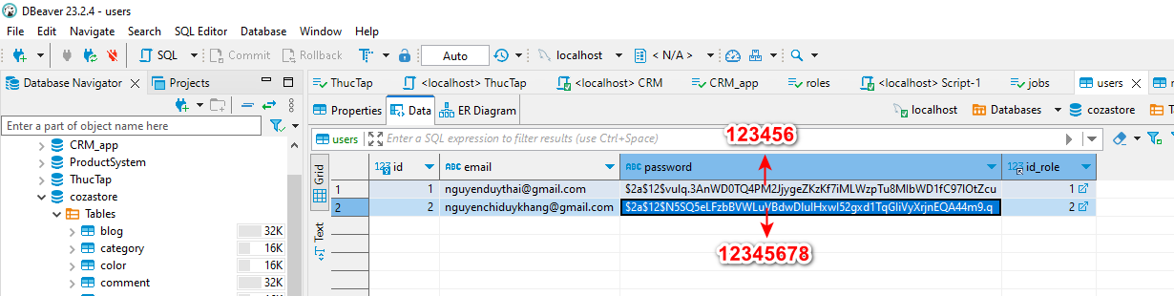

[nguyenduythai@gmail.com](mailto:nguyenduythai@gmail.com) : 123456

[nguyenchiduykhang@gmail.com](mailto:nguyenchiduykhang@gmail.com): 12345678